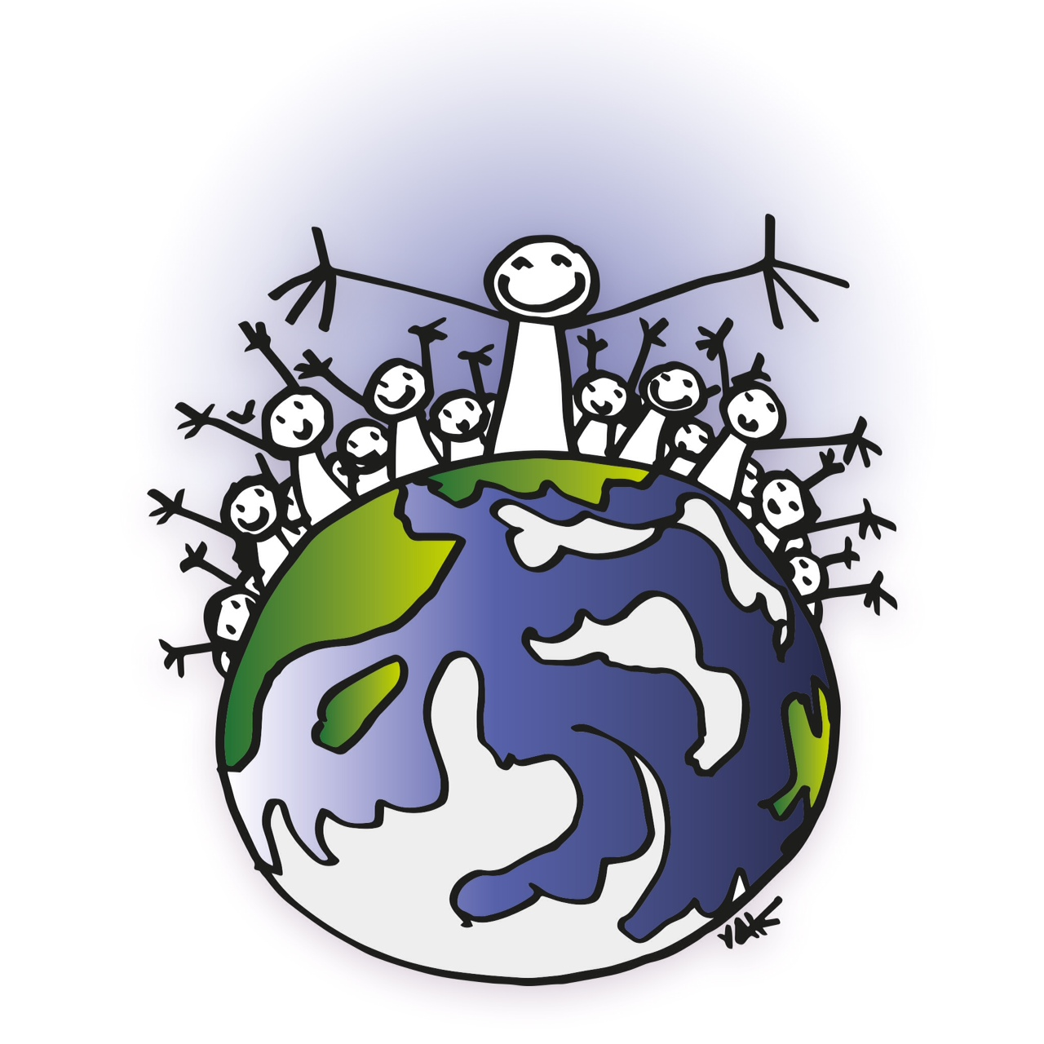

DIALOGUES FOR HUMANITY INTERNATIONAL NETWORK

MANIFESTO
THE EMERGENCE OF PLANETARY CITIZENSHIP
Transforming the Vision of Politics and Geopolitics:
from Dominant Power to Co-creator Power

The big geopolitical issue today is not which Power will dominate the 22nd century, but whether there will be a 22nd century for Humanity. Human civilization is threatened with extinction. But what threatens it is its ecological and social irresponsibility – its own inner barbarism – rather than barbarism from the outside.

This changes the way we see the issue of security and defense. Both terms, in the military sense, come from a politics based on the idea that nations are built in confrontation with external threats embodied in “enemies.” The relation to this external enemy is essential in this kind of politics and geopolitics, from Sun Tzu to Clausewitz to George Bush. The notion of external threats leads governments to justify wars as necessary; leaders often attempt to unite the nation against whoever is the “enemy” at the moment. The idea of an external enemy, whether real or fabricated, may conveniently serve to distract the country from internal problems like social inequality and class oppression.

The notion of planetary citizenship focuses on security as a challenge broader than security in the military sens. Security is related to the right to life, which implies access to food, education, health, a healthy environment and all other aspects of life in society that make Good Living materially possible. The necessary change of paradigm involves, therefore, a shift of military security and defense toward Good Living for all inhabitants of our Common Home. The human family that inhabits the Planet becomes the reference, and the threats are no longer external, but rather internal.

One internal threat is a mode of development harmful to ecosystems because reduced to “unlimited” growth; or the appropriation of resources by a small number of people, enterprises and countries that exclude the majority of humans from the right to property and Good Living. This blind mode of economic growth hinders the majority from living in communities that practice the politics of sharing, collaboration and peace rather than egocentrism, competition and war. In a positive light, the new paradigm of planetary citizenship is founded on the development of human potential, individual, collective and planetary, in harmony with the natural milieu.

Good Living, therefore, consists of the ability of humans to organize a way of living together with security on the planet so that it remains habitable. Ecological and human concerns, rather than profits and capital accumulation (i.e., the capacity of humans to confront their internal demons and grow in humanity) become the center of a new approach to geopolitics. This holistic, planetary view of the place of human beings in nature is more compassionate and constructive than the conventional view of the world as composed of competing individuals and nation-states. Every human being naturally becomes a citizen of the Earth: small and at the same time responsible for the present and the future of the whole. By nature, we tend toward humility and solidarity because we know each one of us is only one fragile element of the family of all living beings.

This change of perspective requires changing modes of life in four areas.

POLITICAL

It is necessary to move from dominant Power, which underlies classical geopolitics, to co-creator Power. This means a change in the notion of governance, a qualitative transformation of competitive and delegative democracy to forms of Participatory and Collaborative Democracy. It is also the passage from a politics founded on enmity (the figure of the enemy) to one Aristotle and Derrida called a "politics of friendship," founded on the idea that the daughters and sons of Mother Earth can only survive by overcoming their violent drives. This does not mean the end of conflicts or disagreements, but the ability to understand them in a positive and non-violent way. This distinction is important both in interpersonal relationships and in interactions within planetary civil society in all its diversity.

JUDICIAL

The proposed transformation suggests a change in our legal vision too: a transition from the "solitary sovereignty" of nation-states to "solidary sovereignty", one that respects the sovereignty of others and takes into account ecological and societal "common goods" (not only the goods of nature but also knowledge and power to manage them wisely). This idea is already supported by new legal developments, such as the notion of ecocide, a crime against the environment that puts humanity at risk. Today, whenever a crime against humanity of an environmental nature is proven, the International Criminal Court has the authority to pass judgment.

The legal recognition of ecocide obliges us to view the planet as the common home of all living species. This is a departure from pure “inter-nationalism,” in which the world is seen as composed of diverse nation-states. In truth, the reality of the planet fragmented into different nation-states exists side by side with the reality of a planet united by a common origin and destiny. A “global vision” opposes globalization that is only financial; instead, it takes into account global ecological and social issues starting at the local level. Through the lens of a global vision, each community is responsible for managing its own space, supported when necessary by larger-scale levels (territories, countries, continents). This practice also allows the construction of relationships based on mutual respect and trust between communities and between different levels. Therefore, planetary citizenship gives every human being rights and duties defined in the Universal Declaration of Human Rights and in the Earth Charter. This makes planetary citizenship compatible with local, national or continental citizenship. It involves the shared responsibility between different scales of life for the survival of the Earth’s people.

ECONOMIC

This change in perspective requires a change in relation to the economy. Economic development must be seen as a mere means to achieve the development of individual and social freedoms. Such change requires a fully ecological economy that promotes awareness of the need for responsible management of all our homes: our bodies, our houses, our communities, our biomes, our countries and the great planetary house. This management requires an economy of enough that recognizes the finite nature of the earth's resources, promotes sober and responsible consumption, and plans production within the limits of ecosystems. It requires new indicators of wealth and an approach to accounting that salvages the true meaning of the term “beneficial activities:” sources of qualitative improvements for all, rather than merely quantitative improvements for just a small number of privileged people. This contrasts with an economy in which money is generated by speculative activities or those destructive of life and ecosystems, such as the commodification of human labor, wars, diseases, planned obsolescence, aggravation of natural disasters (extractivism or anarchic constructions) and addictions like cigarette smoking.

What matters in a house is the Good Living of all who inhabit it. The true meaning of economic activity should be living in fullness, rather than treating profit or accumulation of wealth and property as ends in themselves. Living in fullness includes having access to all conditions that facilitate the development of the potentials, qualities and talents of each person, community, territory and people. The shared ownership and management of productive assets – land, industry, finance, technology, knowledge and time – fosters solidarity, reciprocity and complementarity.

Good Living leads to other profound changes. One is the shift away from private enterprise as the sole director of economic activities toward a plural economy, in which self-managing communities work in solidarity with one another. In these communities, participatory planning of self-managed socioeconomic development guides the economic and knowledge flows to the production of goods and services that respond to the real needs of people. It also promotes Politics as a non-hierarchical mode of governance organized from the local to the general spheres. This vocation of Politics as service to holistic Good Living applies to the democratic State, whose responsibilities include the:

- Orchestration of social diversity
- Democratic creation of laws and regulations to guide relationships among humans, institutions and the environment
- Protection of human rights and the sovereignty of people and nation
- Promotion of harmonic and egalitarian relations between communities and regions with respect for diversity
- Democratic planning and management of socioeconomic development, including the use of natural assets and the production of infrastructure serving the regional and national spheres
- Assurance of responsible management of common goods, biomes and ecosystems
- Protection of environments altered by human action
- Management of international and planetary affairs.

SPIRITUAL

Good Living also leads to a change in relation to spirituality. Good Living implies an open spirituality founded on a relationship with beauty, and the mystery of interiority that allows one to transcend religions organized around fear, guilt, submission and sacrifice. Open spirituality overcomes the logic of dominant power, which deeply corrupted various institutions and led to the worst wars – those carried out in the name of God. This open, creative and non-oppressive spirituality can then be fully consistent with freedom of belief. Spirituality becomes, therefore, an intimate search for the profound mission of each and every person, which leads us to practice the joy of living with oneself, with others and with Nature. This notion changes the understanding of the relationship between human beings and the cosmos from a view that separates the micro and the macro dimensions of reality to a view of the interconnectedness of both. Instead of seeing the inner separated from the outer, we see that they are mutually interactive. This new understanding opens the way for a transformation that is at the same time personal and social.

CIVILIZATION

The notion of civilization is changing. The perspective of a world citizenship offers an alternative not only to the idea of a civilization that colonizes, but also to the war of civilizations theorized and practiced by U.S. neo-conservatives. World citizenship calls for a dialogue between Modernity and Tradition, which can preserve the best of both. From Modernity, we will preserve freedom of conscience and the recognition of the uniqueness and rights of all human beings, without the worst of it, which is the commodification of Nature, Life, and even humans. And we will do the same selective sorting between the luminous part of Tradition, which involves the reconnection with Nature, with others, and with questions of meaning while also rejecting its shadowy part: dependence derived from patriarchal domination (social control, identity-based fundamentalism, and misanthropic ecology).

It is the whole perspective of humanism that is transformed: the co-construction of humanism at the service of Life and planetary citizenship, rather than a humanism that dominates nature and imposes a Western worldview.

The challenge of "Good Living"

The vision expressed by the native peoples of Latin America and the Caribbean disseminated forcefully from the World Social Forum of Belém (Brazil) in 2009 proposes a transition toward societies of "Good Living" (Sumak Kawsay in Quechua) and of “Living Well” (Sumak Qamaña in Aymara), which makes sense for today and creates the spiritual path our world needs.

But Good Living will not become a true project of society unless it is embodied by a citizens’ movement that takes the project seriously enough to organize itself around this vision and carry out concrete actions. We must respond to the challenge of experience and not only of hope. The simplicity of the 13 steps proposed by the peoples of the Andes to express Sumak Kawsay in daily life can serve as an inspiration to all who wish to undertake personal as well as social transformation. Transformation begins with everyday life on the individual scale and expands toward the scale of the whole of global society. It is a new meaning of life that expresses itself in the search for "Living Fully" in the holistic sense: Good Living with ourselves, with those around us and with Mother Earth. The 13 principles of Good Living concern knowing how to:

1) nourish oneself with what is healthy
2) drink favoring the flow of life
3) dance in the rhythm of the Universe
4) sleep from one day to the next
5) work with joy
6) be quiet and seek meditative silence
7) think, in connection with the heart and the spirit
8) love and be loved
9) listen to oneself, others and Mother Earth
10) speak constructively
11) dream of a better reality
12) walk accompanied by good energies; and
13) give and receive.

The transition toward societies of Good Living is no longer just a dream but is already being carried out by new types of citizen movements. Their innovations are attracting growing numbers of people who wish to join them and to demonstrate that such societies are achievable on a grand scale.

We must build a true "alliance of the forces of life," capable not only of resisting murderous logics, but also of promoting the transition to Good Living societies, inspired by movements who try to live their dreams here and now, such as the Convivialist Movement, Transition Towns, the Gaia Education Program, the global Ecovillage Network, Nación Pachamama, the Intercontinental Network for Promoting Social Solidarity Economy (RIPESS), the Educational and Entrepreneurial entity of Gawad Kalinga in the Philippines, and in India, Ekta Parishad (Gandhian Rajagopal Movement) and Vikalp Sangham (an extensive network of alternative movements). To this we add all the initiatives worldwide that demonstrate a formidable creativity and innovative power.

In any transformative movement, there are important conflicts that must be superseded. If not fully understood, these conflicts can weaken a project’s creative potential or cause it to fail. Historically, many alternative projects failed not due to the strength of their opponents (capitalism, despotism, imperialism, for example), but from fratricidal rivalries. A second source of failure may result ironically from the success of the movement itself; leaders may become complacent, leading to a diminishing of the movement’s creative energy. In analyzing the causes of these failures, we find that forms of bad living and mistreatments were often present within these movements. Part of bad living, whether collective or individual, results from seeking the causes of problems outside rather than inside. This produces rivalry in personal relations (sexism, racism, class rivalry), a predatory relationship with nature, and depression. As an outcome of these internal dysfunctions such failed movements frequently morphed into brutal forms of governance.

The need to avoid these pitfalls as we create truly democratic forms of governance is obvious. Several movements based on self-management and shared leadership, that values the contribution of each person, confirm this increasingly conscious need. These collectives grow stronger and more attractive, especially to youth, because they seek change here and now and foster bonds of friendship as a political force. A politics of friendship and trust rests on the benevolence of one towards the other, on welcoming differences, but also on the requirement of individual and collective responsibility in upholding shared values. These collectives, thanks to their ability to build unities within diversity, can become a major force for the transformation of the world. Examples of transformative movements historically successful include those started by persons such as Rosa Luxemburg, Rosa Parks, Wangari Matthaai, Leymah Gbowee, Rigoberta Menchu, Nelson Mandela, Desmond Tutu, Martin Luther King and Gandhi, whose famous quote sums up the philosophy of these new citizen movements: "Be the change you want to see in the world." This principle was also taken up by Pope Francis in his Encyclical "Laudato Si."

Good Living generates joie de vivre, and it constitutes an alternative to the economy of poor living, scarcity and mistreatment. According to the United Nations, annual drug and narcotic expenditures represent ten times the cost of meeting the vital needs of humanity. The money spent on arms, which generates war and death around the world, is twenty times the cost of supplying humanity’s vital needs. Advertising, which fuels this economy of poor living to better feed the rush to HAVE, is also considered worth ten times more than the sum needed to eradicate hunger or allow access to clean water or basic care.

Poor living results in a lack of inner joy, which leads people to seek compensation in what the philosopher Spinoza called “sad passions.” Poor living in ecological terms results in insatiable productivism, extractivism and consumerism. Only a happy sobriety and an economy of enough have the power to reverse this deleterious process.

How can agents collaborate for "the Great Transition" better coordinate on a global scale? Planetary citizenship is an ambitious global project that allows all the creative energies currently fragmented to converge in their diversity and expand. Let us get together around this common project! Let us develop common tools of communication to facilitate the convergence of our actions! Let us create symbols of belonging to our great family to make our movement visible! This visibility is essential so that its members can say, “Yes, we have the power to act! Yes, we are at home anywhere on the planet! Yes, we are all citizens of the People of the Earth! Yes, we can experiment with new ways of life that are ecologically and socially desirable!”

We are still a fractal cell of this world citizen movement for Good Living. The great projects in History have always started small. If many agents are ready to co-construct such a project in spaces such as the World Social Forum, it could quickly expand. Together we can help bring to light this innovative and complex paradigm. This paradigm is pluralistic, presupposing multiple approaches informed by a common vision and demanding concrete actions. It will call for innovations on a trial-and-error basis, such as new spaces of creation, new forms of relationship, new transversal themes, new hierarchies of values, and a new language to be created together with the collaboration of all creative people in all fields: cultural, economic, political, religious, agnostic, and spiritual.

To further this vision, the Dialogues for Humanity International Network proposes that the convergence of perceptions achieved during the “Summit of Consciences”, held parallel to COP21 in Paris (2015), be translated into the creation of a Humanity Security Council.

In the face of major threats - such as financial crises, ecological disasters, social upheavals, weapons of mass destruction, etc., - we propose a common Project for our movements: the creation of a Humanity Security Council by a world civil society. Such a Council is needed because the United Nations Security Council is far from its mission of promoting peace with justice; its five permanent members, who should have the greatest responsibility for the challenge of world peace, are also the top five arms dealers.

An authentic Humanity Security Council would combine two types of resources. On one hand, it needs large civil society organizations working in the ecological, humanitarian, social and technological fields to produce warnings and counterproposals about the great risks facing Humanity. On the other hand, we need a "Council of Wise Persons," with the function of advising the Humanity Security Council. This would allow a firm and transparent dialogue with the current UN Security Council. Such a Council of planetary citizenship could manifest an awareness of the future of our human family beyond all economic, political, or religious interests.

A first challenge would be to participate in mobilization called Mission 2020, a call published in the journal Nature in June 2017. In this appeal, several celebrities propose concrete changes in six fields of action that would result in a significant reduction in greenhouse gas emissions. This would give Humanity about twenty more years in which to continue its attempts to decelerate climate change.

Aside from Mission 2020, we need an alliance of citizen forces, great scientific and spiritual agents, and people in positions of political or economic responsibility. This co-construction could be the first subject the Humanity Security Council Project could address in its attempt to mobilize collectively a planetary citizens' movement.

Text proposed on behalf of Dialogues in Humanity by Patrick Viveret, Débora Nunes, Marcos Arruda, Anne Marie Codur, Christine Bisch, Siddhartha, Laurence Baranski, Geneviève Ancel et Hugues de Rincquesen.

Contact of Dialogues Network in Brazil (English and Portuguese): Débora Nunes (Salvador, BA): rededeboranunes@gmail.com and Marcos Arruda (Rio de Janeiro): marcospsarruda@gmail.com

https://www.nature.com/news/three-years-to-safeguard-our-climate-1.22201

